Bash Script Tasks
- Create a bash script to check if a directory is available or not.

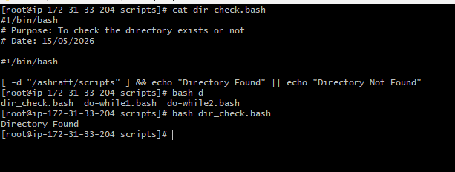

- Create a bash script to create multiple files.

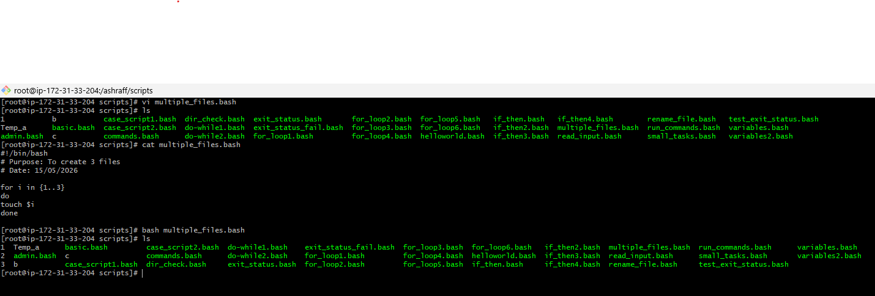

- Create a bash script to take a backup of a directory.

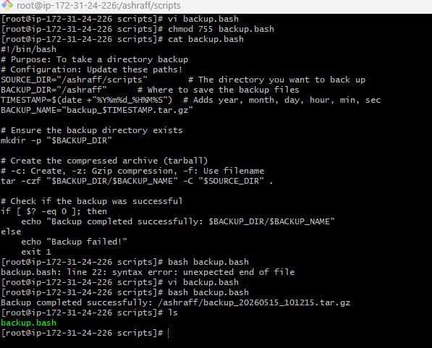

- Create a bash script to install Nginx on an EC2 server.

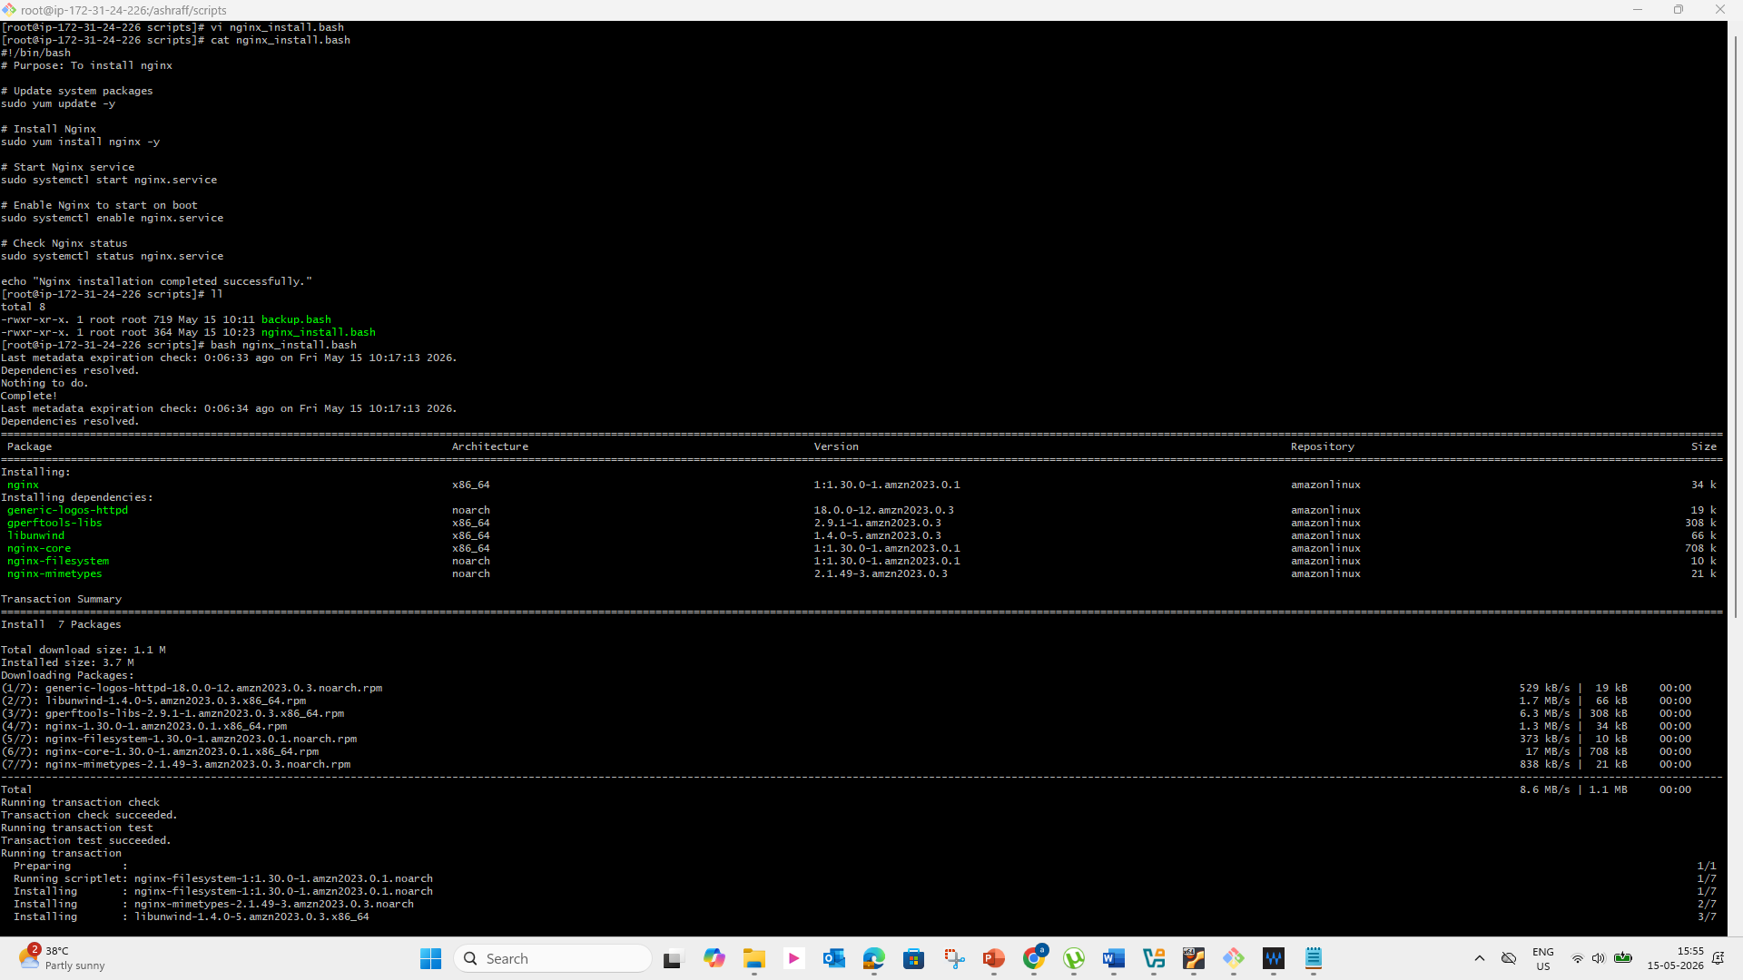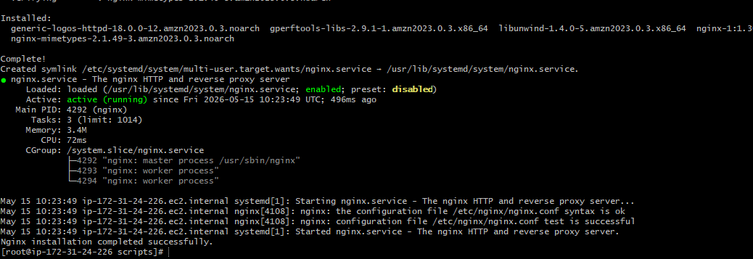
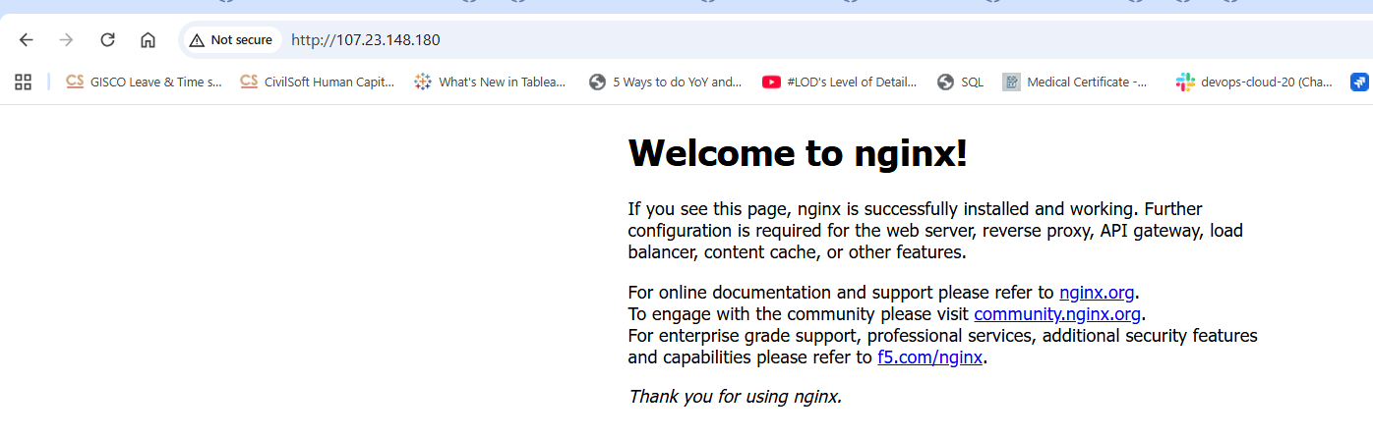

- Create a bash script to install Apache Tomcat on an EC2 server.

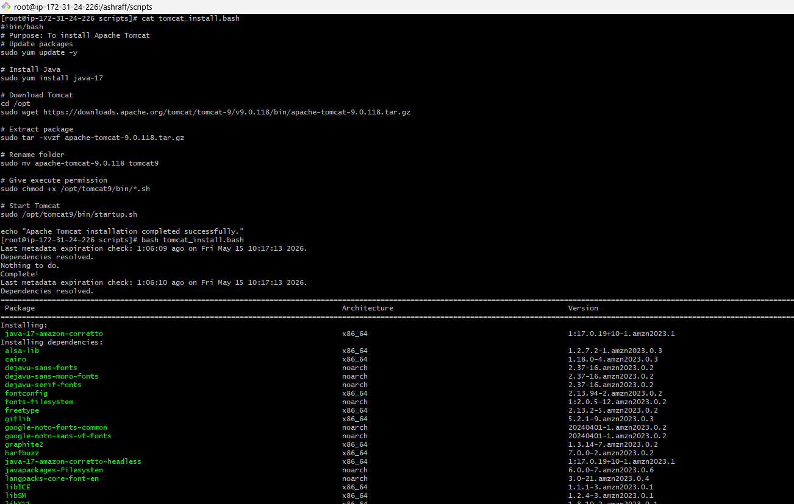
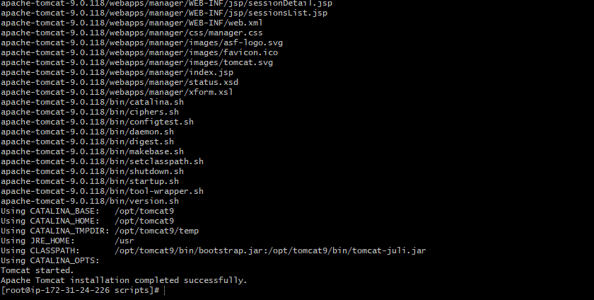

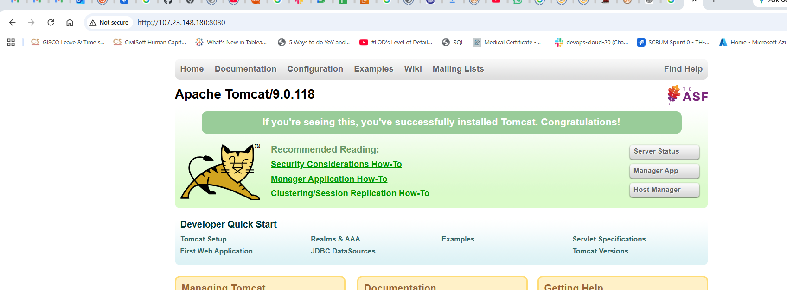

- Create a bash script to check if the Nginx service is running, if not running then script should start the service.

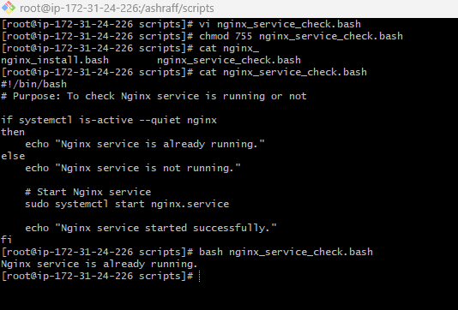
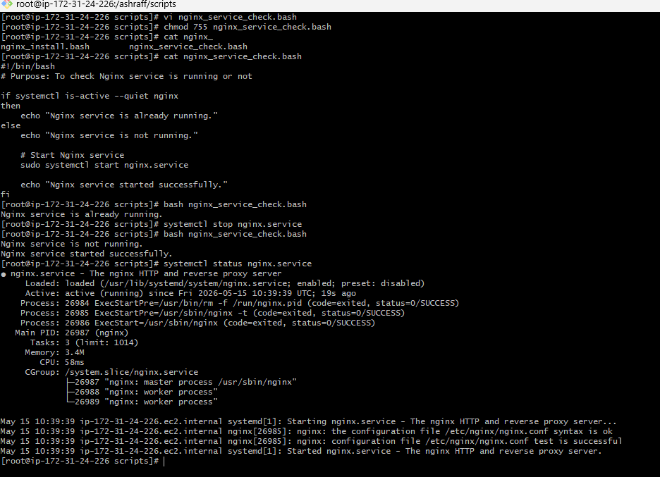

- Create a bash script for a calculator.

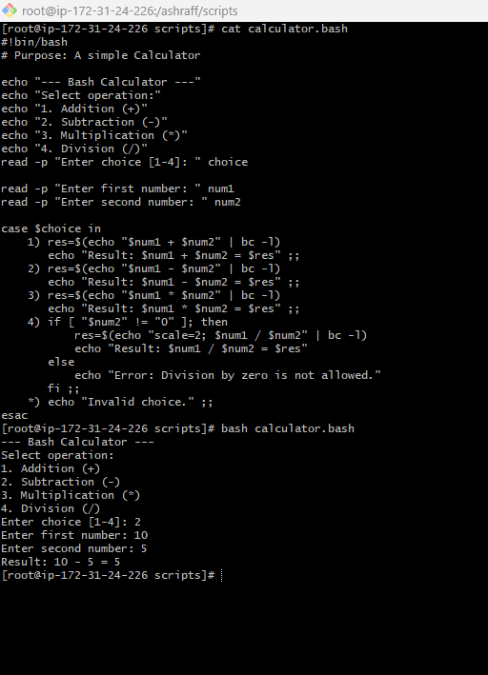

- Create a bash script to check if a directory exists, if not then create a directory.

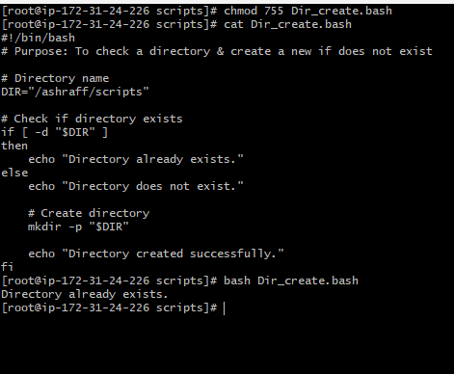
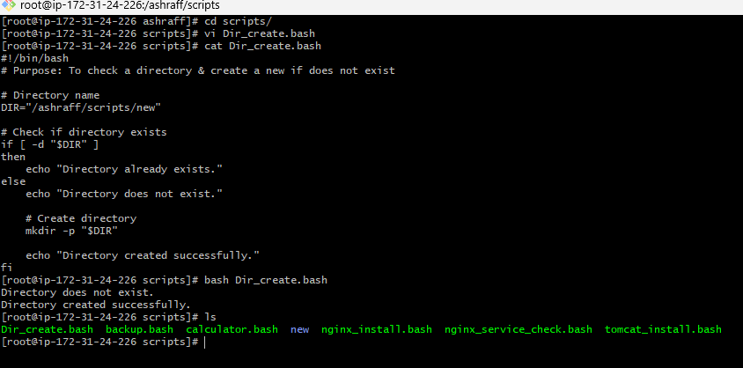

- Create a bash script to delete the last 3 lines of a file.

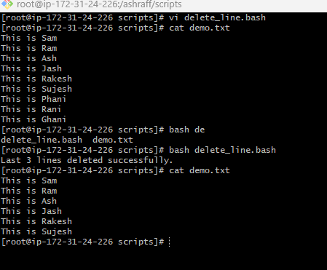

- Bash script to monitor cpu and if it is more than 80% then send email notification.

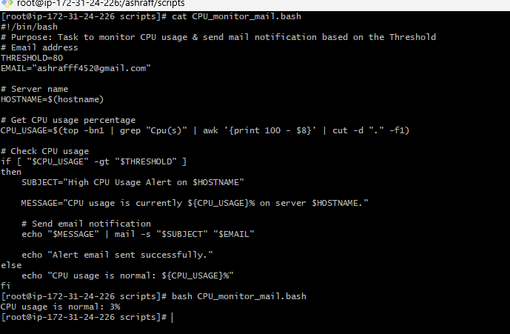

- Bash script to monitor disk space and if it is more than 80% then send email notification.

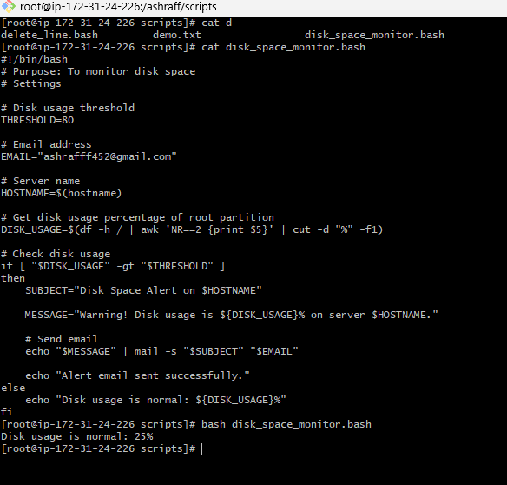

- Bash script to monitor memory and if it is more than 80% then send email notification.
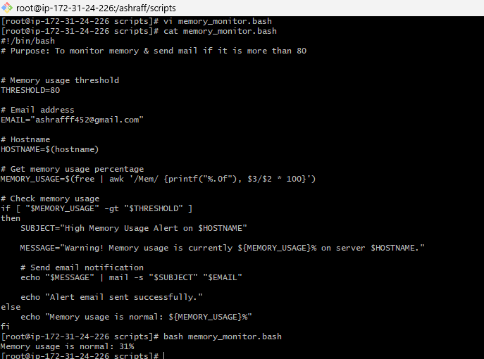

Exercise: Crontab Entries
- April 5th Midnight
- 5th of Every November, January, June if it is a Thursday
- At05 and 27th minutes of 9, 10, 11hours every day
- 34 minutes of 9th houron15th August
- Every midnight
- Every Weekend (Saturday night 11:59 PM)
- After every reboot

